

Ben-Gurion University of the Negev

Faculty of Engineering Science

School of Electrical and Computer Engineering

Dept. of Electrical and Computer Engineering

Final Year Engineering Project

Final Report

Unmanned Surface Vehicle for Searching and Survey of shallow water bodies

|  |  |
| --- | --- |
| **p-2023-115** | **Project ID** |
| **Yuval Avigdor – 203387097**  **avigdory@post.bgu.ac.il**  **Yonatan Axelrad – 311366249**  **axelray@post.bgu.ac.il** | **Students** |
| **Hugo Guterman** | **Supervisor** |
| - | **Sponsors** |
| **30.07.2023** | **Submission date** |

Table of Contents

Abstract: 3

Introduction 5

Specifications Sheet 7

Design Proposal 9

Software development and final testing 12

Problems and Solutions 16

Conclusions and recommendations 18

Reference: 23

Table of Figures

Figure 1: System schematic layout 7

Figure 2: Taken by Side Scan Sonar (Klein uuv 3500) 8

Figure 3: Main chamber design 9

Figure 4: Initial configuration (left) and final configuration (right) of main chamber 10

Figure 5: Side-Scan Sonar chamber design 11

Figure 6: The Sealed Chamber and Mounting Platform of the Sonar 11

Figure 7: The Circuit Boards and Heat Dissipation Plate of the Sonar 11

Figure 8: Software project structure 12

Figure 9: Budget table 21

Figure 10: Schedule 22

**Unmanned Surface Vehicle for Searching and Survey of shallow water bodies**

Authors: Yuval Avigdor (avigdory@post.bgu.ac.il), Yonatan Axelrad ([axelray@post.bgu.ac.il](mailto:axelray@post.bgu.ac.il))

Adviser's name: Prof Guterman Hugo.

**Key words**: Side scan sonar, ASV, AUV, Seabed, Real-time communication.

# Abstract:

Of all the different types of water reservoirs, this project will focus mainly on shallow water bodies (*e.g. small lakes, fish pools, drinking water reservoirs etc.).* It is important to keep in mind the fact that many of these bodies of water are known to have interference factors like water pumps and muddy waters.

Over the last decade, more and more people are realizing the need in surveying the seabed of these bodies of waters, both for ecological research and also police matters such as recovering human bodies thrown in.

The project aims to implement a design that can be rapidly deployed in the field and that can navigate its way in shallow water reservoirs. Using different sensors, the system will give the users a better understanding of what the area underwater looks like and even where certain objects are.

Solutions offered today mostly make use of AUV (Autonomous Underwater Vehicles) that mainly send information to the user at the end of the run, due to limited bandwidths of acoustic modems.

The solution proposed in this project is instead an autonomous Kayak-based ASV (Above Surface Vehicle) that uses real-time communication to transmit data from sensors such as a side scan sonar, camera and GPS to an operator in a remote location. The platform will be implemented with a guidance system that would allow it to receive a pre-determined route and move by it.

Having real-time data will ensure that the platform doesn't waste time and power. With a real-time image, the operator could decide to end a mission if he sees the desired object, rather than waiting for the run to end and seeing what data the vehicle gathered. Moreover, an autonomous operation will cut expenses by reducing the need of human work force.

**תקציר**

מאגרי מים קיימים בהרבה צורות וגדלים, ועם סוגים שונים של מים. פרויקט זה יתמקד בעיקר על מאגרי מים רדודים, כמו מרינות ימיות, בריכות דגים או מאגרי מים לשתייה. כמובן שיש לקחת בחשבון שהרבה מגופי המים האלו מכילים הפרעות כמו מים בוציים או משאבות.

בשנים האחרונות הרבה חברות מנסות להשיג שיפור של היכולות לחיפוש תת מימי, ליכולות אלו שימושים רבים, לדוגמה:

1. מציאה והחזרה של ציוד וטכנולוגיה צבאית.
2. עזרה לכוחות הביטחון באיתור של גופות או עצמים שהוסתרו מתחת למים.
3. מיפוי של קרקעית הים במרינות לצורך שיט בטוח.

מטרת הפרויקט היא לשלב מספר מערכות וחיישנים על כלי שיט, לצורך ביצוע של מגוון משימות.  
הכלי יצטרך להיות מסוגל לנווט את עצמו לנק' ציון שנקבעו מראש ע"י המשתמש, בעזרת מידע בזמן אמת ממערכת ניווט לוויינית. הכלי יסרוק את הקרקעית תוך כדי תנועה והקלטה של המידע שנאסף. בפרויקט זה יעשה שימוש בעקרונות שפותחו עבור כלים אוטונומיים שתוכננו במיוחד עבור מאגרי מים.

הפתרונות שקיימים היום בתעשייה לרוב עושים שימוש במערכות תת מימיות אשר מקליטות את המידע ומעבירות אותו למשתמש רק בהגעה לחוף עם סיום המשימה, בעיקר בגלל בעיות של רוחב פס קטן בתקשורת תת ימית. חלק מהחברות עושות שימוש בכלים אוטונומיים תת מימיים [1] אשר דורשים בכבל פיזי לצרכי תקשורת שיוצר בעיות אחרות של מוגבלות בתנועה ומרחק.

הגישה המוצעת בפרויקט הוא שימוש בכלי על-מימי (קיאק) אשר יעשה שימוש בתקשורת זמן-אמת ויעביר מידע מכל החיישנים שלו כגון מערכת ניווט לוויינית, חיישן מגנטי, סונאר [2] ומצלמה. העברת המידע תעשה באמצעות אנטנת WIFI להעברת רוב המידע ובנוסף תקשורת LoRa [3] להעברת נתוני טלמטריה בסיסיים.

העברה של כל המידע למשתמש בזמן אמת תשפר את הסיכויים למשימה מוצלחת. במצבים שבהם המשתמש יכול לראות את המטרה בעין יחסך זמן רב על חיפוש המטרה והמשתמש יוכל לשלוח את הקיאק אל האובייקט ישירות. שילוב של שימוש בתקשורת זמן אמת ותכנון המסלול מראש יביא לדיוק גבוה יותר בסריקות וחיסכון בזמן שנדרש לבצע את הסריקות.

# Introduction

During [Operation Guardian of the Walls ("SHOMER HA'HOMOT"),](https://www.gov.il/en/departments/topics/the-guardian-of-the-walls/govil-landing-page) a foreign aircraft penetrated the borders of Israel, and was shot down and crushed into a large fish farm. Despite many efforts to recover the aircraft, the task proved too challenging because of the large size of the area, turbidity in water, and its complex surface characteristics.

Consequently, Ben Gurion University's Autonomous Robotics Laboratory (LAR), guided by Professor Hugo Gutterman, was asked to employ the HydroCamel2 submarine to aid retrieving the aircraft. Unfortunately, the vehicle's functionality was less effective owing to its acoustic medium operation and the difficulty in relaying real-time information to operators. Additionally, navigation in relatively shallow water (2 meters) was a difficulty.

Following these complications, the idea of a dedicated vehicle to navigate similar terrains more effectively and transmit sonar images in real-time emerged. After engaging with various experts in the field of maritime exploration, the idea to develop an autonomous kayak was materialized. The current focus is on the development and optimization of this vehicle.

The project's main goal is to design an autonomous surface vehicle (ASV) that maneuvers and scans small reservoirs using sensors (such as side-scan sonar, and cameras) and transmits the data in real-time to a remote operator. Receiving the data in real-time significantly helps the remote operator in locating the desired objects. It also offers flexibility in adjusting the mission directives while still in operation, to enable a full scanning of reservoirs.

The primary goal of the project is to implement the autonomous guidance system that will allow the ASV to keep its route, as well as implementing monitor modules for all sensors used on the platform (e.g. Side scan sonar, Camera, Magnetometer, GPS etc.). The data collected from these sensors will be sent to a remote operator in real-time. This will enable the remote operator to detect desired objects, adjust the mission as needed while it is in progress, and make more efficient mission plans.

The main goal can be broken down into:

* Establishing full communication with all sensors and receiving a clear picture from the sonar.
* Implementing control modules for motors.
* Working with a mechanical engineering team to figure out the optimal positioning of both the motors and the sonar.
* Developing software (coding with Python) that would integrate all modules and communicate between them. The communication between modules is ROS2 based.

**Measure of success:**

The project will be considered successful under the following conditions:

1. A clear image can be transmitted by the sonar and received by a remote computer.
2. The platform can successfully maneuver directed by a remote operator .
3. The platform can navigate itself by receiving target waypoints and a final run time.

At roughly 300 meters the expectation is that high-bandwidth data will be received, and at around 2 Kilometers, low-bandwidth data will be received.

# Specifications Sheet

The platform for this project is an autonomous Kayak-based ASV designed for real-time seabed mapping. The ASV's movement is controlled by a guidance algorithm using target waypoints and local positioning data received via an onboard GPS.

The main chamber houses the project's electronics and is mounted atop the Kayak before operation. An UP ™ board computer uses the ROS2 system to manage communication between the sensors and control the motors.

The Sonar, housed in a sealed chamber equipped with environmental sensors, is mounted below the kayak before operation. In order to prevent overheating of the casing, a heat dissipation plate was added to the sonar.

Figure : System schematic layout

* Batteries: Two cells of lithium batteries.
  + Voltage: 28.8V nominal.
  + Capacity: 49.5Ah.
  + Pack Power: 1425Wh.
* Motors: Two Torqeedo Ultralight 403A Pylon motors
  + Max. input power 400W
  + Max. propulsive power 180W
  + Total weight 8.8kg.
* Computer: UP Board series
  + Intel® ATOM™ x5-Z8350 Processors 64 bits up to 1.92GHz.
  + 4GB DDR3L RAM
  + 64GB eMMC.
  + 4x USB2.0 on connectors.
  + UART on header.
  + I2C on header.
* Location: GPS sensor (NEO-M8N) for real time position and navigation system.
  + Update rate up to 10 Hz.
* Side Scan Sonar:  Klein UUV-3500, survey the underwater surface.
  + Operation frequencies - 455 kHz, 900 kHz.
  + Beam width - horizontal: 0.34°, vertical: 45°.
  + Typical range - 150 m @ 455 kHz, 75 m @ 900 kHz.
  + Multibeam Bathymetry – 125 m nominal/side (typically 10 to 12 times altitude) @ 455 kHz.

Figure 2: Taken by Side Scan Sonar (Klein uuv 3500)

# Design Proposal

The system has three main parts:

* Main chamber, which contains sensors and communications.
* Side-scan sonar chamber.
* Motors.

**Main chamber**: The main chamber is mounted on the platform, connected to a 28v battery. The chamber is an IP67 proof electricity box with the following design:

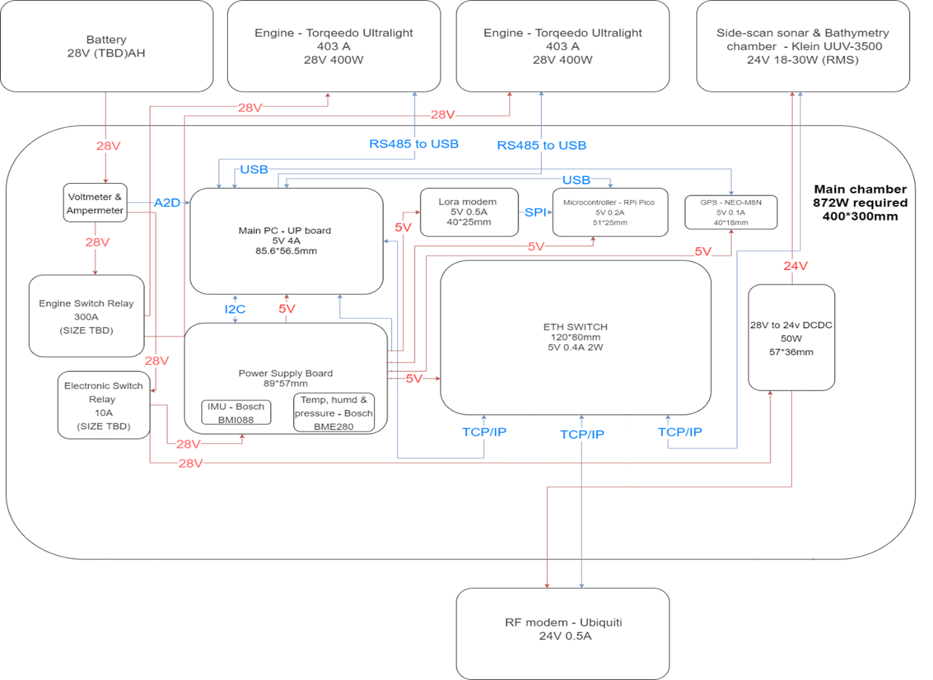

Figure 3: Main chamber design

Following the inspection for faulty components, which were subsequently replaced, the entire system was assembled, and any missing components were added.

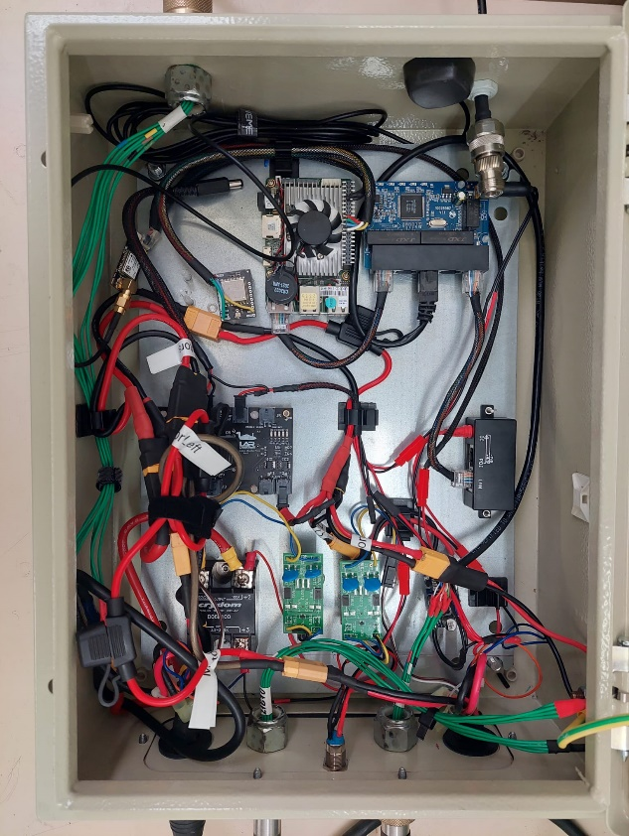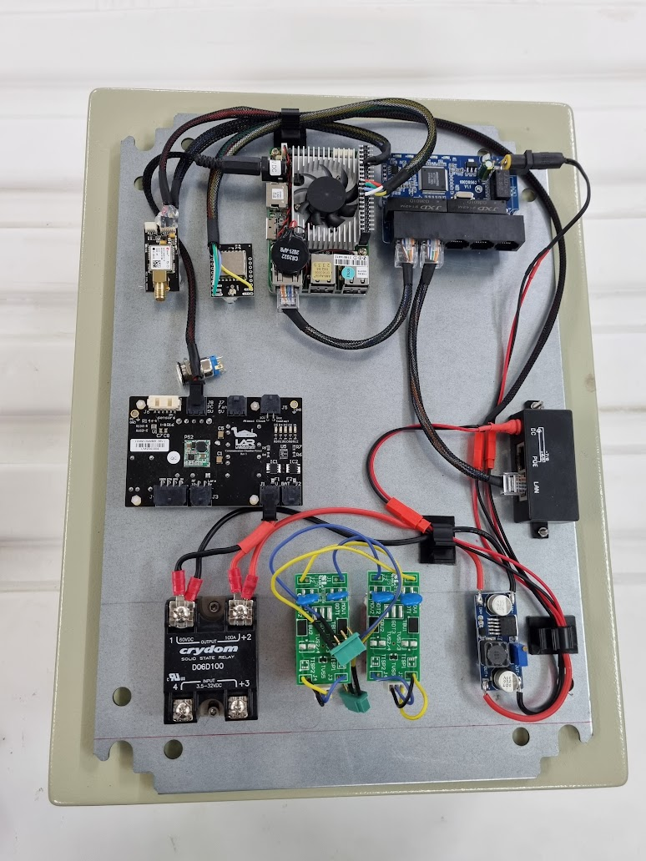

Figure 4: Initial configuration (left) and final configuration (right) of main chamber

**The side-scan sonar chamber:**

The side-scan sonar transducers are located beneath the ASV, as they need to be submerged for operation. Due to the requirement for maximum heat dissipation and cable length limitations, the sonar chamber is also mounted beneath the ASV. The chamber is completely waterproof up to a depth of 300 meters, with all attached connectors and cables also being waterproof. For continuous monitoring of the chamber's sealing integrity, an environmental sensor is incorporated to measure pressure, humidity, and temperature.

Figure 5: Side-Scan Sonar chamber design

Figure 6: The Sealed Chamber and Mounting Platform of the Sonar

Figure 7: The Circuit Boards and Heat Dissipation Plate of the Sonar

**Motors:**

The platform uses Torqeedo Ultralight 403A Pylon motors which are equipped with position sensors. These sensors ensure that if the orientation of the motors isn't correct, all operations will stop immediately. Communication with the motors is made via Ethernet (RS485 to USB).

# Software development and final testing

The vehicle software was developed in a ROS2 environment using Python with the overall system designed to support all necessary hardware devices. The configuration is structured around several packages, with individual nodes contained within each package. These nodes are tasked with managing various end units.

The main component of this system is the autopilot package, which collects information and manages both the mission and communication with the user side.

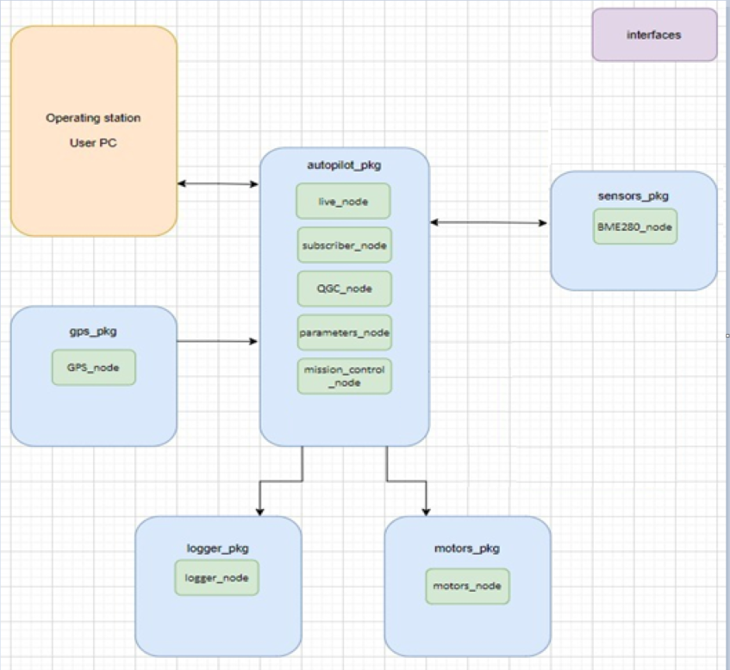

Figure 8: Software project structure

The vehicle is configured to communicate with the QGroundControl (QGC) software, installed on the operator's computer, through a Mavlink protocol. This software will be referred to as the project's GUI from now on. The user interface displays information obtained from the kayak's environmental sensors, data transmitted from the engines, and a real-time GPS point. It is also designed to allow for manual control of the vehicle using a joystick.

**Autopilot package**

QGC node:

This node is responsible for all communication with the operator's computer. Messages, aligned with the Mavlink protocol, are communicated through the UDP protocol. This sets up the kayak side as the UDP server and the user side as the UDP client. Every message from the operator's computer is processed by a parser, which extracts information from the packet based on the message type. This information is then relayed to the relevant nodes through the publisher.

Additionally, the node receives messages from the BME sensor, which records temperature, pressure, and humidity data. Each message received is formatted as a Mavlink message and dispatched to the user's computer for display in the GUI.

The node enables transmission of the vehicle's local parameter file to the GUI, allowing for necessary modifications and updates in the vehicle's local file.

It also facilitates the transfer of a mission to the vehicle, detailing a set of waypoints the vehicle is programmed to reach.

Parameters node:

This node manages the vehicle's parameters file. The parameters file is where mission limits such as distance and speed are defined. Also, parameters of the PID controllers (KP, KD, KI) can also be set.

The GUI (via the QGC node) requests the local parameter file, which the parameter node afterwards sends, releasing the parameters individually. This process also allows for the sending, receiving, and modification of a single parameter if necessary.

The parameters file, in the form of a JSON file, is loaded into a Python dictionary. Any changes made to the node parameter are published immediately, making the information accessible to any interested node.

Live node:

This node handles the safety of the vehicle.

The vehicle's systems are monitored, and alerts are activated if any faults that could pose a problem are detected. The environmental sensor is also being monitored, if the temperature, pressure, or humidity exceed the set maximum values (hard-coded), an error message is dispatched.

To constantly check the proper working of all nodes and prevent any failures, all vehicle systems are regularly monitored using a timer. If a message is not received from a particular system, an issue is identified and a corresponding message with information about the non-responsive system is sent to the operator.

Alerts include going out of range, loss of communication with shore, loss of GPS communication, and humidity or overheating inside the system.

Mission control node:

This node controls the vehicle's state machine, overseeing the transitions between different modes as needed. For instance, to operate the engines with the joystick, the system needs to be in PAUSE mode. For the kayak to engage in a mission, the system must be put in STOP mode beforehand, ensuring that the battery is sufficiently charged and the vehicle has a predetermined mission, among other necessary conditions. Additionally, the mission control node is responsible for ensuring that the kayak reaches its preset target and stays within a 3-meter radius of the target. This is done by continuously monitoring the kayak's position and adjusting its course as needed.

**GPS package**

GPS node:

This node serves as the conduit for data reception from the GPS. At a frequency of 1Hz, the location is requested from the GPS and then published to the other nodes.

**Logger package**

Logger node:

This node is used for recording all communications that pass through the vehicle, allowing for potential task investigation if necessary. To achieve this, the node is configured to monitor all existing systems, storing the information in local files that can be later downloaded and analyzed.

**Sensors package**

BME280_node:

This node functions as the driver for sampling the BME280 device (I2C) and acts as a server that delivers services to the client (the package publisher). Environmental data samples can be requested, Once such a request is received, the device goes through a calibration process, following which, data related to temperature, humidity, and pressure are collected and subsequently forwarded to the publisher that initiated the request

**Motors package**

Motors node & data handler:

The communication with the Torqeedo Ultralight 403A Pylon motors is managed by the motors package. The motors, linked via an RS485 to a USB adapter to the computer, engage in a multithread serial session created by the package, initiating communication with each motor. A data handler which is responsible for the Torqeedo communication protocol is included within this package, parsing received bytes to extract data, and composing a complete packet to be sent to the motor. A specific order of commands is necessary to operate the motors and receive the RPM in return. Messages are transmitted from the joystick through the GUI to the QGC node and redirected to the motors node, causing the motors to operate as instructed.

# Problems and Solutions

1. Failed communication with sonar: The sonar system failed to establish communication with the main computer. The manufacturer did not respond, but eventually responded via email, and provided instructions for a factory reset. The factory reset was successful, and communication with the sonar system was established.
2. Closed-source motors code: The motors in the kayak are closed-source, meaning that the code for the motors is not available to the public. This made it difficult to communicate and troubleshoot problems with the motors. However, with the help of a senior programmer from the lab, the code was partially reverse engineered, which allowed for communication but not for full troubleshooting of the motors.
3. Malfunctioning motors: One of the motors malfunctioned, resulting in the purchase and shipping of a replacement motor taking a significant amount of time. However, the replacement motor also malfunctioned a few days before the kayak could go to sea in a field experiment, which caused the cancellation of the field experiment. This was because our code is written for two motors, and we could not go to sea with just one motor, which requires a different steering approach.
4. Voltage spikes: The voltage of the kayak's battery system occasionally spiked when running on batteries, causing malfunctions with the electronics. The voltage spikes were caused by the nature of batteries, which can deliver a large amount of current in a short amount of time. To address this issue, a voltage regulator needs to be added to the project. This will regulate the voltage and prevent the spikes from occurring.
5. Burned electronic card: The sonar computer's electronic card was burned due to a voltage spike that occurred when the kayak was running on batteries. This caused to a loss of communication with the sonar. The sonar computer had to be disassembled to find the malfunctioned card and replace it.
6. Water resistance: As the vehicle operates in a marine environment, all connections must meet the waterproofing standard. The batteries were placed in a waterproof chamber, and the connections between the compartments and the battery were made using connectors and cables designed for work in a marine environment.
7. Navigation loop and state machine: The navigation loop and state machine were difficult to implement due to the complexity of the task. The navigation loop is responsible for controlling the kayak's movement, while the state machine determines the kayak's current state and what actions should be taken. The theoretical concepts of navigation and state machines are well-established, but the practical implementation of these concepts can be challenging. In particular, it was difficult to ensure that the navigation loop was accurate and that the state machine was robust.

# Conclusions and recommendations

In this project, we designed and assembled the essential components of the kayak platform. We integrated electronic and mechanical systems, and fixed any design or hardware problems that arose. We also incorporated the vehicle's primary communication with the operator's remote computer for operation and control. We made progress in programming by enabling the vehicle to autonomously execute tasks between waypoints transmitted to it. We used PID controllers to regulate the vehicle's movements and manage its travel route. For safety, we integrated mission kill parameters into the system, which allows for a safe termination of the mission in an emergency.

Our work can be extended in several ways:

* Adding a voltage regulator to the batteries, this is the most critical improvement, as it will assist in preventing voltage spikes that could damage the batteries.
* Improved maneuverability with a single motor and servo for direction, this would make the kayak easier to maneuver and would also allow for more precise control of the kayak's direction.
* Installing a front-facing camera: This camera could be used to perform image processing to detect the edges of water reservoirs. This would allow for the identification of water reservoirs for which no prior mapping exists.
* Installing a depth camera: This camera could be used to identify objects in the water, such as bodies. This would be a valuable tool for search and rescue missions.
* Adding other sensors: Depending on the specific needs of the user, there are many other sensors that could be added to the kayak platform. For instance, a temperature sensor could be used to monitor the water temperature, or a magnetic sensor could be used to detect the presence of metal objects in the water.

Advantages:

* Large size: The large size of the kayak allows it to carry our systems and remain stable in the water, preventing it from overturning. This is especially important for search and rescue missions, as the kayak must be able to withstand rough water conditions.
* Sealed chamber: The presence of the sealed chamber in the water helps to keep the sonar from overheating, as heat conduction in water is much better than in air. This is important for long-duration missions, as the sonar must be able to operate for extended periods of time without overheating.
* Two motors: The use of two motors provides more thrust, which allows the kayak to travel faster. This is important for search and rescue missions, as the kayak must be able to reach the search site quickly.

Disadvantages:

* Size: The size of the kayak makes it difficult to transport to search sites. This is a major disadvantage, as it can limit the range of the kayak and make it difficult to deploy in remote areas.
* Electrical cables: The electrical cables connecting the transducers to the sonar body are short, which means that the sonar chamber must be placed in the water. This can be difficult to do, as the chamber must be sealed to prevent water from entering.
* Two motors: The use of two motors makes the kayak more difficult to maneuver. This is because the circular movement of the motors creates turbulence in the water, which makes it more difficult to control the kayak's direction. Additionally, the two motors can be difficult to coordinate, which can make it difficult to keep the kayak on a straight course.

Despite the challenges mentioned earlier, we were able to make significant progress on the project. We completed the kayak's hardware design, software development, and partial testing. We also tested the communication system from 2 kilometers away and verified that it was functioning properly.

Specifically, the cancellation of the field experiment in Eilat was a significant setback. This experiment was intended to test the operating system, including the navigation system, the mission kill parameters, the kayak's control efficiency, and its ability to stay within the specified target radius. The failure of the motors prevented us from conducting this experiment, which limited our ability to fully test the kayak's capabilities. Another obstacle we faced was waiting for hardware to arrive from abroad.

However, we were able to use a simulator to test the kayak's operating system in a virtual environment. This allowed us to test the kayak's capabilities to a limited extent. Overall, we believe that the project was a partial success. However, we also believe that the scope of the project was too ambitious for two students to complete in less than a year. We would recommend that future projects of this nature be undertaken by a larger team of students.

Thanks to our careful planning, we were able to meet the planned budget for the project.

Total budget:

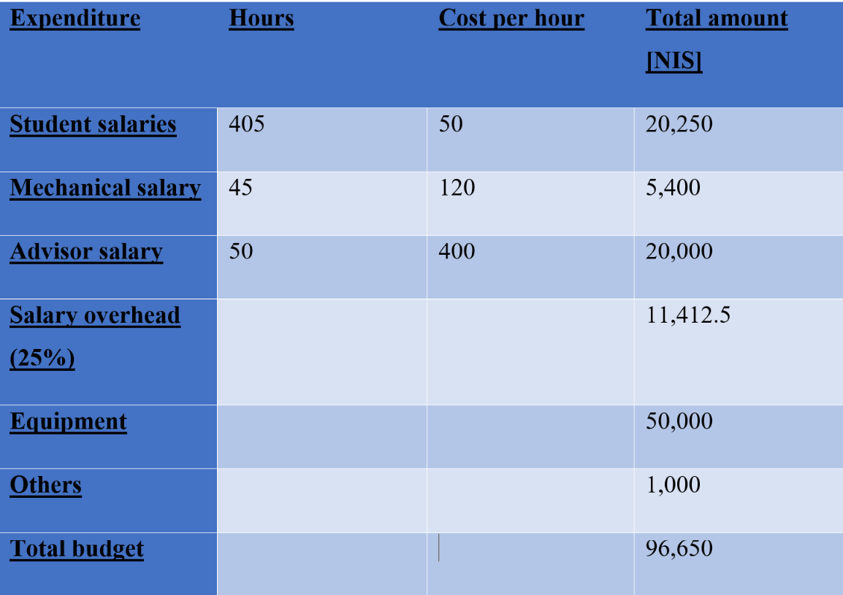

Figure 9: Budget table

The project schedule encountered two primary challenges. The first was the initial difficulty of establishing communication with the sonar instrument. This was eventually resolved. The second challenge was a recurring malfunction in the motors, which ultimately led to the cancellation of a field experiment. Despite these challenges, the project team was able to adhere to the planned schedule for the remainder of the project. A picture containing plot, line, diagram, text

Figure 10: Schedule

# Reference:

[1] P. Kimball et al., "The WHOI Jetyak: An autonomous surface vehicle for oceanographic research in shallow or dangerous waters," 2014 IEEE/OES Autonomous Underwater Vehicles (AUV), 2014, pp. 1-7

[2] A. Vasilijevic et al., "An ASV for coastal underwater archaeology: The Pladypos survey of Caesarea Maritima, Israel," OCEANS 2015 - Genova, 2015, pp. 1-7

[3] Jung, J.; Lee, Y.; Park, J.; Yeu, T.-K. Multi-Modal Sonar Mapping of Offshore Cable Lines with an Autonomous Surface Vehicle. J. Mar. Sci. Eng. 2022, 10, 361.

**המלצת ציון לדו"ח מסכם**

אם יש צורך, לכל סטודנט/ית בנפרד

מספר הפרויקט: _____-____20-P

הפרויקט:

שם המנחה החיצוני:

שם המנחה מבית הספר:

שם הסטודנט/ית: ת.ז.:

|  |  |  |  |  |  |  |
| --- | --- | --- | --- | --- | --- | --- |
| % |  | חלש  55-64 | בינוני  65-74 | טוב  75-84 | ט"מ  85-94 | מצוין  95-100 |
| 20 | הצגת גישת הפתרון, והתכנון ההנדסי |  |  |  |  |  |
| 20 | הצגת התוצאות וניתוח השגיאות |  |  |  |  |  |
| 20 | הסקת מסקנות |  |  |  |  |  |
| 10 | גילוי יוזמה וחריצות |  |  |  |  |  |
| 20 | פתרון בעיות, מקוריות ותרומה אישית (מעבר למילוי ההנחיות) |  |  |  |  |  |
| 10 | עמידה בלו"ז ורמת הביצוע המעשי |  |  |  |  |  |

אם יש כוונה לפרסם/ יפורסם מאמר, שם כתב העת ומועד משוער להגשה:

ציין אם יש כוונה לשקול המלצה כפרויקט מצטיין:

הערות נוספות: